Revision & Date : PVFL30103

PVFL Series

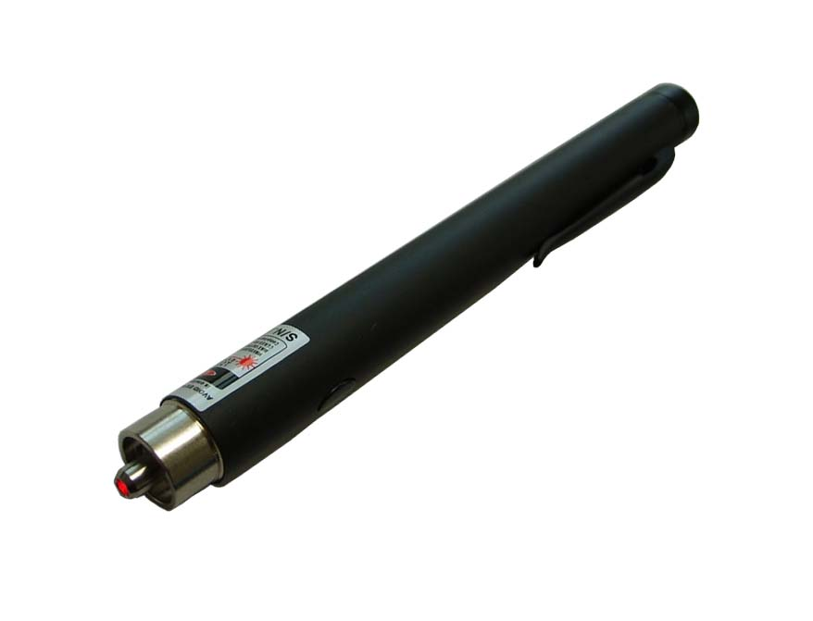
Pen Type Visual Fault Locator

Special Features :
Visual Fault Locator is used for locating broken point in fibers
Visual Fault Locator is equipped with a 650nm visible laser diode
Can be operated in continuous or pulse modes
Available 2.5mm and 1.25mm ferrule both
Power switch on the end for battery on / off
Push button operate CW / Pulse / Pause
Light Weight

Specifications :
Central Wavelength | 650 +/- 5 nm
Fiber Compatibility | Multimode and Singlemode
Output Power | >0.5 mW(-3dBm) into Single-mode fiber
Output Port | Universal accept any connector with 2.5mm ferrule
Output Mode | Continuous or Flashing (3Hz)
Spectral Width | < 20 nm
Transmission | CW or 2.5 Hz pulse
Batteries | 2 x 1.5V AAA Alkaline; 40 hours typical in continuous mode
Operating Temp. | 0℃ to 40 ℃ 0 to 95 ℃ RH (non-condensing)
Storage Temp. | -20℃ to +60℃ 0 to 95 ℃ RH (non-condensing)
Detection Distance | < 3 Km
Dimension / Weight | 13.5(dia) mm X 146(length) mm / 80 g (include battery)
Light Source | Class 3A laser diode

Ordering Information :

P/N: PVFL : For 2.5mm Ferrule (standard), TIP-1.25: For 1.25mm Ferrule (option)

TheFibers
C R E AT I V E F I B E R S
TheFibers Inc.
A-1109 Keumkang Penterium IT Tower, 282 Hagui-ro, Anyang-City, Korea
Tel: +82-31-381-6108 Fax: +82-31-381-6109 sales@thefibers.com

